café sci

beer
+ science
= good conversation

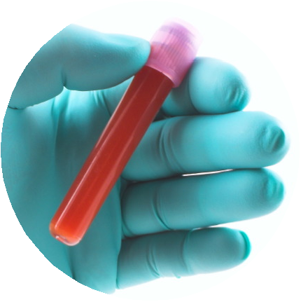

DO YOU FIT IN
A TEST TUBE?

featuring

with

George Church,

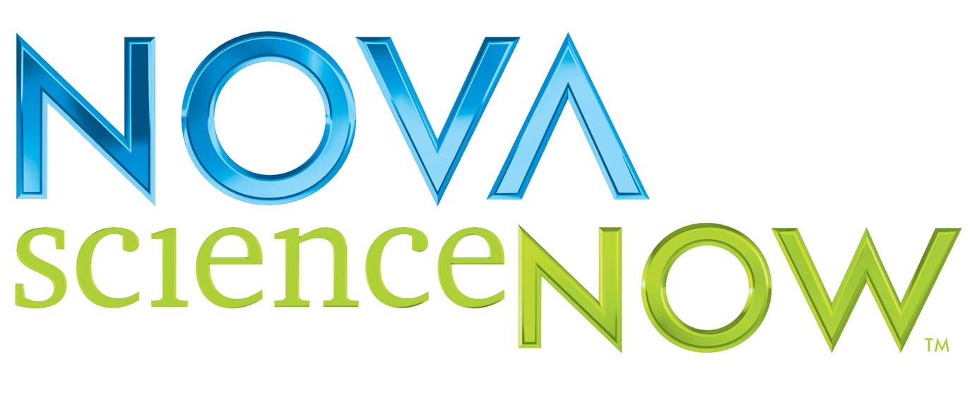
Come and talk it over
in plain language.

Are genetic traits INEVITABLE?
Who has access to test results?

Cheap and easy
GENETIC TESTING
Can prevent diseases but poses
ETHICAL CHALLENGES…

FREE FOOD
DRINK SPECIALS

Tuesday, April 24
starts @ 6:30 pm

The Thirsty Scholar

Inman Square

70 Beacon St.

info: getinvolved@wgbh.org

Harvard
University
NOVA scienceNOW is a registered trademark
of WGBH Educational Foundation.

